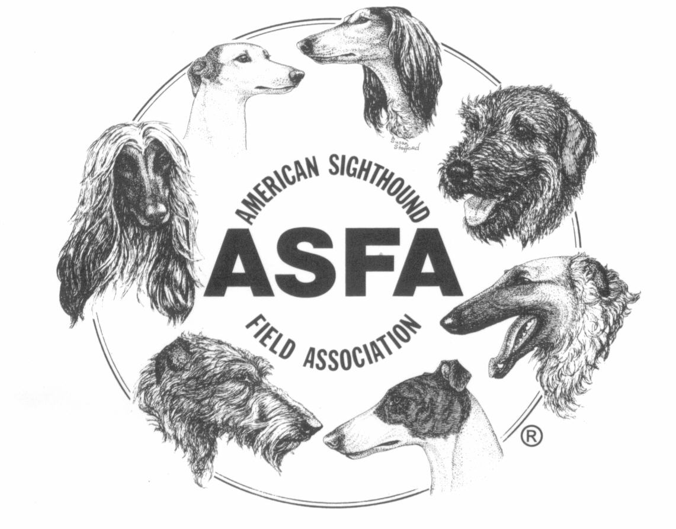
AMERICAN SIGHTHOUND FIELD ASSOCIATION
HALL OF FAME NOMINATION FORM - HOUND

Dog’s Registered Name:
Call Name: |  |  | Breed:
Owner’s Name(s):
Owner’s Address:
Titles Held:
Include all coursing, performance and conformation titles
Lure Coursing Record:
Include all lure coursing & racing accomplishments including but not limited to BIF, BOB wins at breed specialty trials, II's, Regionals, and premier trials (e.g. the Grand National)
Date last trial entered:

Hound’s Birthdate: |  | Breeder:
Sire:
Dam:
Biography: Provide a brief biography of this hound. Limit 250 words. Biography written by:
Nominating Club:
Officer Name and Title:
Club Officer's Signature:
Date Nominated:
Attach additional pages if necessary
Procedures for Nominations:
Hounds:
Any ASFA club may recommend one hound on an annual basis to be considered for the Hall of Fame. Recommendations should be submitted on the form provided for this purpose and signed by a club officer.
Submit two photos of the nominated hound if possible. It is preferred that one photo be a still, standing or "stacked" photo and the other be a running or action photo of the dog.
The form should be submitted to the Hall of Fame Committee Chair no later than the date selected by the committee and published on the ASFA.org website for that year.
The hound should be retired and have not entered a trial in the last five years. To get the correct date of the last trial a hound entered, please contact the ASFA Records Coordinator at records@asfa.org.
The hound should have great coursing accomplishments, including a long coursing career with a top-winning record, however, great achievement in a short time span will be considered.
The committee will then select ten hounds to be voted on by delegates convening at the ensuing Annual Convention of Delegates (ACoD).
In the event that there are not at least ten hounds nominated by clubs, the Hall of Fame Committee may nominate additional hounds to bring the total to ten. The Committee will first consider hounds previously nominated and not elected, but may also nominate hounds not previously nominated.
Three hounds will be chosen for the Hall of Fame by written ballot. A picture and biographical sketch of each hound elected into the Hall of Fame will be entered into the appropriate historian's album. The Hall of Fame Committee shall award each year at the ACoD certificates for hounds inducted into the ASFA Hall of Fame.
Hounds Not Elected:
If a hound nominated to the Hall of Fame is not elected, it shall automatically be placed on the ballot for the following year. If the hound is not elected in its second year on the ballot, the nomination process must be repeated to place them on the ballot again.

